Monitoring / On-Call Approval Form

Employee Name: Nikunj Adhaduk _

Manager Name: Vlad Rabenok .
Monitoring Hours
Date of Monitoring (mm/dd/yyyy) | Project | Reason | Number of Hours
TOTAL

On-Call Payment
Dates On-Call (mm/dd/yyyy – mm/dd/yyyy) | # of Weeks | Rate
TOTAL
Approvals
Employee Signature:  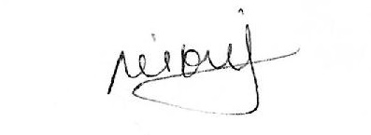 | Date:  April 25, 2024
Manager Signature: | Date:  April 25, 2024

Please submit to Payroll once approved.

Description
Date of Monitoring (mm/dd/yyyy) | Hours | Reason
March 13, 2024 | 2 | BNS deployment for streaming job changes and support for scene deployments.  CR-14011
March 27, 2024 | 2 | Scene & BNS deployment this is BNS second deployment to replace service bus instead of HTTP call at APIM for entire BNS API’s.  CR-14023
April 1, 2024  April 2, 2024 | 2.5 | Website sign in down due to DDOS attack and evening investigation with Abrar and Team  It is related to token endpoint.  The second day after analysis help ITOPS and BTS creating more enhanced rule at Imperva.

